**OBJECTIVES**

By the end of this module, you should be able to:

* Understand the need for prediction to evaluate alternatives relative to objectives
* Construct a consequence table and use it to qualitatively compare alternatives
* Build an influence diagram
* Explain the role of modeling and desired properties of models in decision analysis
* Understand the roles of both empirical estimation and expert judgment in prediction of consequences

**PREDICTION**

***Predicting consequences***

* How should we select the best alternative?
* We want the best outcomes from our decision
* We need to predict what we think would happen in the future if we implemented each of our alternatives
* What are the outcomes of interest?
* Fundamental objectives (and associated measurable attributes) define what we care about in a decision

***Single‐objective examples***

* Commuting to work
* Objective: arrive on time for a meeting at 8:30 am
* Alternatives: leave home at 7:30, 7:45, or 8:00 am
* Consequences: how long will it take to get to the office?
* Regulated harvest from a population
* Objective: maximize sustainable yield
* Alternatives: annual harvest rates [0–0.3]
* Consequences: predict sustainable yield at different harvest rates
* Set back succession on a 160‐acre grassland unit
* Objective: minimize financial cost
* Alternatives: burn, mow, graze
* Consequences: How much would it cost to burn, mow, or graze the unit?

***Summarizing predicted consequences***

* If your alternatives are on a continuous scale, use a graph
* Predicted consequences are represented by a line

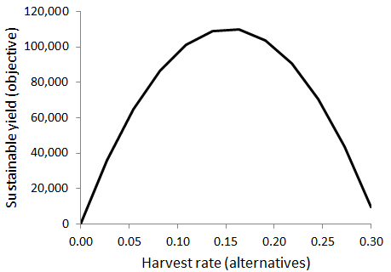

* If your alternatives are discrete, use a table

|  |  |
| --- | --- |
| **Alternatives** | **Cost to treat 160 acres**  **($, objective)** |
| Burn | 800 |
| Mow | 480 |
| Graze | 1000 |

* If there are ≥2 objectives, add an additional column for each objective

|  |  |  |  |
| --- | --- | --- | --- |
| **Alternatives** | **Financial cost** | **Native plant diversity** | **Invasive species control** |
| Burn | 800 |  |  |
| Mow | 480 |  |  |
| Graze | 1000 |  |  |

* Consequence table
* Construct a table with:
* Alternatives in the first column
* Each objective (and measurable attribute) in a separate column
* You can switch this up if it makes it easier for the decision maker to make comparisons
* Benefits
* Summarizes essential elements of the decision problem
* i.e., objectives, alternatives, and consequences
* Facilitates comparison of the alternatives
* Exposes relevance of uncertainty
* Exposes key tradeoffs
* Cultus Lake sockeye salmon conservation example (Gregory and Long 2009)
* Conditional formatting with color can help summarize information in a large table

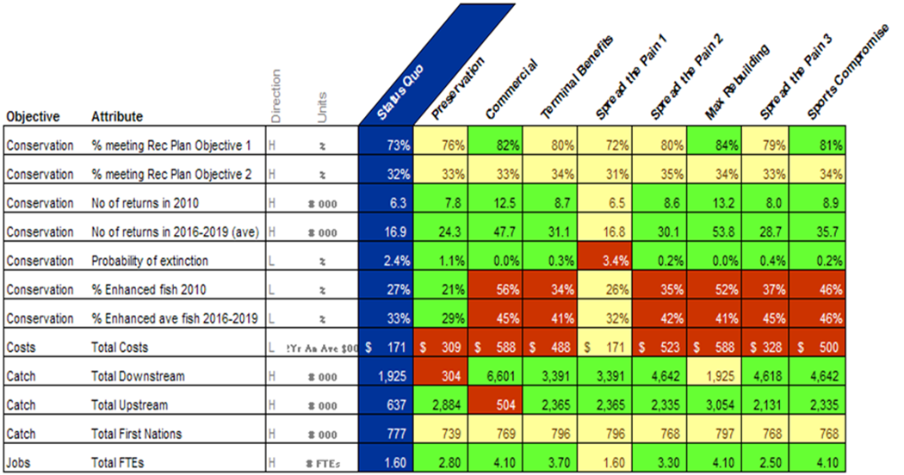

How do you make the predictions (e.g., put numbers in the cells of a consequence table)?

**MODELING IN DECISION ANALYSIS**

Models

* All predictions are based on a model, explicit or not
* A model is any simplified representation of reality intended to be useful for a particular purpose
* “All models are wrong, some are useful” – George Box

***Role of modeling in decision analysis***

* Prediction
* The main need: output of the consequences step of PrOACT
* Want predictions to be “good”
* Better predictions lead to better decisions
* Structuring the analytical problem
* Developing a model helps us with working through the complexity of the system helps us improve and refine our understanding of how the world works
* Decomposing the full system into subcomponents and the relationships among them fosters assessment of what is essential to the decision context and what might not be
* Capturing large amounts of complex information in a way that is accessible
* Transparency
* Every prediction, even a guess, is based upon a model of how we think the world works
* Goal is to describe the model, no matter how simple or sophisticated it is
* Encourages a common understanding among people working on the decision problem
* Fosters communication with stakeholders who are not directly involved in making the decision

***Desired properties of a model in a decision context***

* Model design is driven by the decision context
* Context = the purpose of the model
* The decision may not require a full model of the socioecological system in which the decision is embedded
* Parsimonious
* Includes all essential components of the system that could affect predicting the relevant consequences of possible alternative actions
* Does not include any components that are not necessary for making good predictions, to minimize distractions and unnecessary work
* How do you know if something is essential or unnecessary?
* Incorporates an appropriate articulation of uncertainty
* First prototype of a model often does not include uncertainty (i.e., it is deterministic)
* There is always uncertainty, but is it great enough to be relevant to the decision (i.e., should the model be stochastic?)
* More below in this module (Developing quantitative models) and in Modules 11 (Risk problems) and 12 (Information problems)

***Developing qualitative models***

* How to construct an influence diagram
* Fundamental objectives (measurable attributes) are the model outputs (Hexagons)
* Alternative actions are model inputs (Rectangles)
* Add nodes for system components that link the alternatives to the objectives (Ovals)
* Add arrows to indicate influences
* Add nodes and arrows for other “drivers” that will influence the future status of our objectives
* e.g., sources of mortality other than harvest by hunters
* Remember to seek parsimony – a balance between capturing all essential components of the system and excluding unnecessary components
* Start very simply
* Only add complexity if you think it will be relevant (i.e., will make a difference in predicting consequences to discern among alternatives)

Example influence diagram: Managing common terns on an island in Mille Lacs National Wildlife Refuge in Minnesota (modified from Blomquist et al. 2012, unpublished)

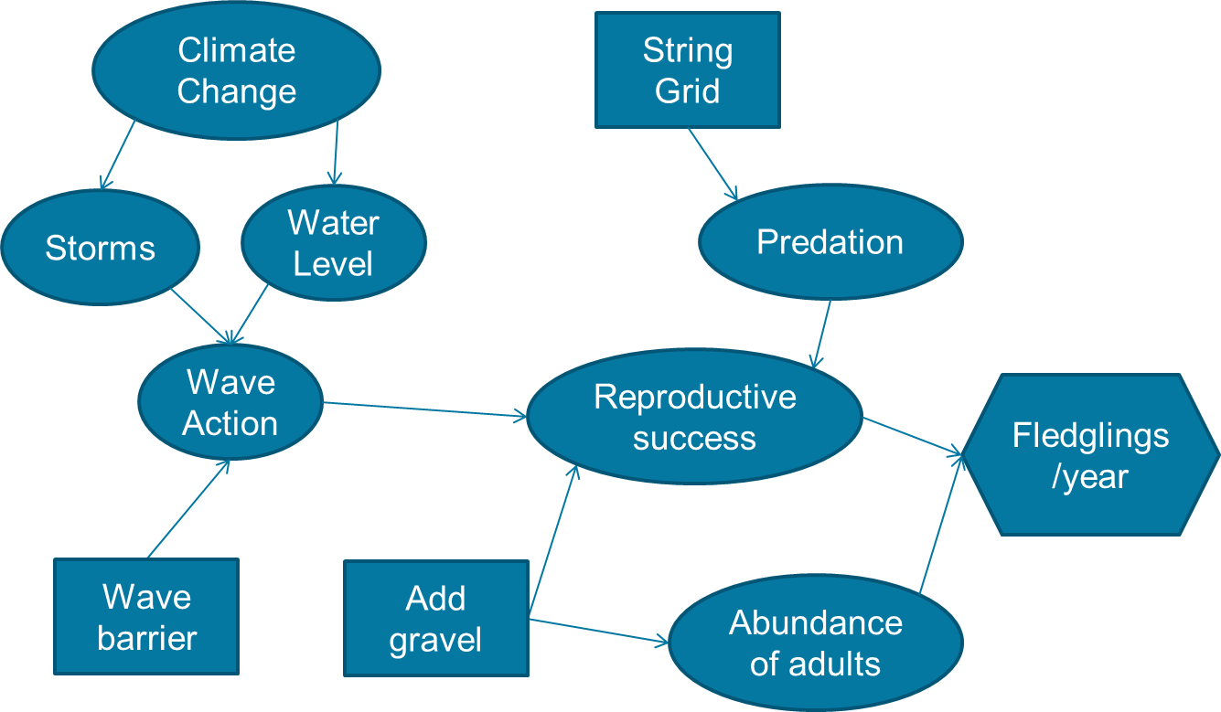

* Value of influence diagrams
* Prediction
* Conditioning people for making expert judgements (i.e., predictions based on informed beliefs)
* See “Expert judgment” = predictions based on informed beliefs
* Basis for developing quantitative models (see next section below)
* Problem framing
* Discussing and making determinations about…
* the relevant spatio‐temporal scale
* what is inside and outside the scope of the decision
* Generating alternatives
* Once the main components and drivers of the system are laid out you can look for new ways to influence the system
* Communication
* Seeking common understanding among stakeholders, justifying a decision to others

***Developing quantitative models***

* Developing the structure of a model
* Selecting the variables, or parameters, to include
* Start very simply, and only add complexity if you think it will be relevant
* Start with an influence diagram
* Convert nodes to parameters in a mathematical formula
* Use iterative prototyping
* Does adding a particular parameter or more complex structure affect the predictions significantly?
* Example: single objective to maximize abundance of a population
* Start with Nt+1 = Nt + Births – Deaths, or Nt+1 = Nt + (Nt × r)
* Is immigration or emigration significant?
* Is density dependence significant?
* Is it beneficial to include different sources of mortality?
* Would the comparison of alternatives be different if demographic or environmental stochasticity were added?
* Estimating parameters
* Empirical estimation
* When empirical data are available and there is time to analyze them
* Rely on robust statistical methods when possible
* Expert judgment
* When empirical data are not available or there is not time to analyze them
* A lack of data often cannot or should not delay a decision
* Elicitation (Martin et al. 2012)
* Experts have knowledge and experience that can be useful in making predictions
* Use a structured approach and established methods for elicitation
* Experts are just as susceptible to cognitive biases as other people
* Expert elicitation is a mature field with established best practices
* Example elicitation methods
* Four‐point elicitation (Speirs‐Bridge et al. 2010)
* Plausible lower bound
* Plausible upper bound
* Most likely value
* Level of confidence that the interval includes the true value
* Delphi method for elicitation from a group
* Elicit judgments individually and independently
* Everyone’s judgments are displayed together but anonymously
* Strictly for review
* Method often modified to include group discussion
* Repeat the first 2 main steps until all experts are comfortable with their judgments
* Benefits
* Prevent anchoring on initial judgments or the judgments of others
* Reduce overconfidence in the precision of judgments
* Minimize the likelihood of group think or the effect of dominance in group dynamics
* Cultus Lake sockeye example:
* many objectives, short time frame
* used existing simulation models and elicitation of expert judgments
* different models for different objectives
* Uncertainty in models
* Structural uncertainty
* Uncertainty about which model structure is best, or whether a variable has an effect
* Can use different models to represent competing hypotheses
* See Module 12 (Information problems)
* Parametric uncertainty
* Uncertainty in the value of a parameter or the effect of a variable
* Can be represented by a confidence interval or probability distribution
* Both types reduce the precision of predicted consequences
* How do we deal with uncertainty in decision-making?
* Make a decision while dealing with risk (Module 11, Risk problems)
* Consider learning before deciding (Module 12, Information problems)
* Learn while managing (Module 13, Dynamic decision problems)
* “…unacknowledged uncertainty leads to **optimistic expectations** that cannot be satisfied… and to actions that are blind to substantial qualitative and quantitative uncertainties that, if they were apparent, **would lead to different decisions.**” (Burgman et al.2005)

**THE INTERACTION OF SCIENCE AND POLICY**

Consequence analysis is a scientific endeavor

* Predictions of consequences should be based upon models that represent the most reliable, unbiased understanding of how the world actually works
* Consequence analysis, however, is embedded in a value‐laden decision context.
* The design of the models that scientists develop and apply should be based upon a decision‐specific purpose
* Scientists need to understand:
* the framing of the decision
* the attributes that will be used to evaluate the alternatives
* Similarly, decision‐makers and policy‐makers do not rely on science alone, but they need to understand the scientific predictions and how they relate to the other decision components

**REFERENCES**

Burgman MA, Lindenmayer DB, Elith J. 2005. Managing landscapes for conservation under uncertainty.

Ecology 86(8):2007‐2017.

Gregory R, Failing L, Harstone M, Long G, McDaniels T, Ohlson D. 2012. Structured decision making: a

practical guide for environmental management choices. West Sussex, United Kingdom: Wiley‐Blackwell.

Gregory R, Long G. 2009. Using structured decision making to help implement a precautionary approach

to endangered species management. Risk Analysis 29(4):518‐532.

Hammond JS, Keeney RL, Raiffa H. 1999. Smart Choices: A Practical Guide to Making Better Life

Decisions. New York, New York, USA: Broadway Books. (Chapter 5 ‐ Consequences)

Martin T, Burgman M, Fidler F, Kuhnert P, Low‐Choy S, McBride M, Mengersen K. 2012. Eliciting expert

knowledge in conservation science. Conservation Biology 26(1):29‐38.

Speirs‐Bridge A, Fidler F, McBride M, Flander L, Cumming G, Burgman M. 2010. Reducing overconfidence

in the interval judgments of experts. Risk Analysis 30(3):512‐523.

Starfield AM. 1997. A pragmatic approach to modeling for wildlife management. Journal of Wildlife

Management 61(2):261‐270.

**MODULE DEVELOPED BY:**

Michael A. Larson, *Minnesota Department of Natural Resources*

David R. Smith, *USGS Leetown Science Center*

Sarah J. Converse, *USGS Washington Cooperative Fish and Wildlife Research Unit, University of Washington*

Jennifer A. Szymanski, *USFWS Midwest Region*

James E. Lyons, *USFWS Patuxent Research Refuge*

Suggested Citation for this Module:

Larson MA, Smith DR, Converse SJ, Szymanski JA, Lyons JE. 2016. Consequences. Module 7 *in* Runge MC,

Romito AM, Breese G, Cochrane JF, Converse SJ, Eaton MJ, Larson MA, Lyons JE, Smith DR, Isham AF, eds. Introduction to Structured Decision Making, 2016 edition. U.S. Fish and Wildlife Service, National Conservation Training Center, Shepherdstown, West Virginia, USA.